Converter Design Group Report
Introduction
The main aim for the project is to design a fully controlled two forward converters that outputs and regulated voltage. In Figure 1, we see a 230V, 50Hz AC supply, replicating a mains supply. This is stepped down to 30V, 50Hz using a XFMR gate drive transformer. This report covers the development of two main sections, the isolated two switch forward converter and the MOSFET gate drive.
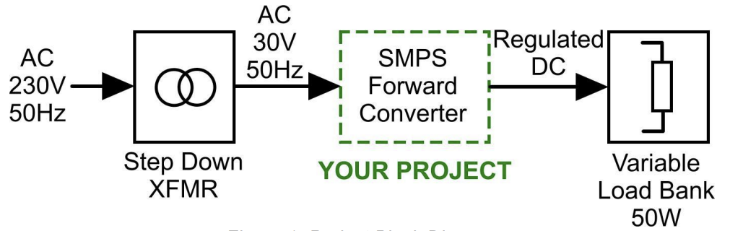
Figure 1. Project block diagram
The task is to produce a stable regulated output voltage across this load bank, regardless of the load. An isolated two switch forward converter is a type of converter that changes the AC input to a DC output. This converter can provide isolated output voltage. This would end up being connects to a 50W variable load bank.
The forward converter was designed and simulated under ideal and non-ideal conditions. Calculating the different components of the forward converter
Control circuits have low voltage and power levels, whilst power MOSFETs have high voltages and powers. Providing electrical isolation between these sections is mandatory to ensure safe and reliable operation. For this, the MOSFET Gate Drive circuit is responsible. Within this report, the operation of the gate drive is explored along with the purpose of each component. The need for coupling capacitors, Zener diodes and several resistors is investigated along with the effect of each component on the signal and the converter. The resultant output is then seen.
This report presents the design and simulation of a forward converter, under both ideal and non-ideal conditions. The initial calculations involved determining the necessary component values, duty cycle, and switching frequency, which in turn allowed for the calculation of important factors such as the turn ratio, output inductors, and capacitors. Non-ideal factors, including the capacitors' Equivalent Series Resistance (ESR), winding numbers, and equivalent resistance, were also taken into account. The simulations of the converter were carried out under ideal and non-ideal conditions, and the effect of an AC-derived input was also explored. The report then delves into the MOSFET Gate Drive circuit, which is crucial for providing electrical isolation between the control circuits (with low voltage and power levels) and the power MOSFETs (with high voltages and powers). The operation of the gate drive and the role of each component, such as coupling capacitors, Zener diodes, and resistors, are explored, along with their effects on the signal and the converter. The report concludes with the resultant output.

Calculations for the Forward Converter
Given values:
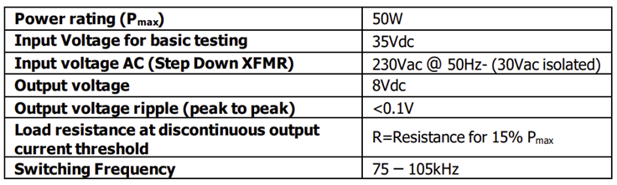
Duty cycle:
For the converter design, the duty cycle was limited to 50% to avoid saturation of the transformer core. Thus, initially, a duty cycle of 40% was chosen. However, a 30% duty cycle provides a higher range of the duty cycle to control the output voltage.
Turns ratio:
$$V_{0}=\left(\frac{N_{1}}{N_{2}}\right)dV_{s}$$
$$\frac{N_{2}}{N_{1}}=\frac{V_{0}}{d∙V_{s}}=\frac{8V}{0.3∙35V}=\frac{16}{21}$$
Switching Frequency:
States anything between 75kHz and 105kHz. Decided on 100kHz.

Output filter inductor:
Use minimum load condition to get $ΔI_{L}$:
$$I_{RMS}=\frac{P}{V}=\frac{50W×0.15}{8V}=0.9375A$$
$$ΔI_{L}=I_{peak}=\sqrt{3}I_{RMS}=1.6238A$$
Voltage time area equation to find the inductance:
$$L=\frac{VTA}{ΔI_{L}}=\frac{VTA}{I_{peak}}=\frac{V_{0}\left(1-d\right)∙T_{sw}}{I_{peak}}=\frac{8V∙0.7∙1/100kHz}{1.6238A}=34.487μH$$

Output filter capacitor:
Use current time area equation to find the capacitance:
$$C_{0}=\frac{ITA}{ΔV_{0}}=\frac{I_{RMS}∙\frac{T_{sw}}{2}∙\frac{1}{2}}{ΔV_{0}}=\frac{0.9375A∙5μs∙0.5}{0.1V}=23.4375μF$$
****************************
In terms of simulation with non-ideal components, the ESR (equivalent serial resistance) of capacitors, the DCR (DC resistance) of inductors, the resistance and forward bias voltage of diodes, the on-resistance of MOSFET, and the losses on the transformer should all be reflected on the schematic. Among all the component values, most could be found on the datasheet of their own, including the forward bias voltage of diodes, on-resistance of MOSFET etc. The following part of this section presents the methods to calculate or estimate the equivalent component values which could not be found on the datasheet directly.

Capacitor ESR Calculation:
The capacitor ESR is dependent to the capacitance and the power dissipation factor which could be found in the datasheet.
The primary part of the converter is operating around 35V and the voltage across output filter is around 10V. Therefore, the dissipation factor chosen for the corresponding capacitors are 0.12 and 0.2. The ESR could be calculated using the equation below:
$$ESR=tanσ∙ Xc=tanσ∙\frac{1}{2πfC}$$
The capacitors placed after the rectifier for smoothing the input voltage works at 100Hz while the capacitors at the output end of the converter are operating at 100kHz, the capacitances could hence be derived:

$$C_{output}=0.2×\frac{1}{2×π×100k×23.4375μ}=0.014Ω$$
$$C_{input}=0.12×\frac{1}{2×π×120×1000μ}=0.16Ω$$

Main Converter transformer winding number calculation
The number of turns on the transformer is determined by the equation below (the derivation steps are skipped):
$$N=\frac{VTA}{ΔBA_{core}}$$
In this equation, the cross-section area of the core is settled (97.1 $mm^{2}$) and VTA is calculated in the worst case scenario, which refers 50% duty cycle. Although the flux density of N87 material saturates at around 500mT from the datasheet, the value of maximum flux density is chosen as 150mT to reduce the losses in the transformer and increase the efficiency. Therefore, the number of windings on the primary part of the transformer:
$$N=\frac{0.5×35×\frac{1}{100k}}{150×{10}^{-3}×97.1×{10}^{-6}}=12$$
According to the primary and secondary turns ratio:
$$N_{2}=N_{1}×\frac{16}{21}=10$$
The magnetising inductance of the transformer could hence be calculated using the number of turns by the equation below:
$$L_{mag}=A_{L}N^{2}$$
Where $A_{L}=2600nH$, $N=12$:
$$L_{mag}=2600n×{12}^{2}=374μH$$
The magnitude of magnetising current could be calculated based on $L_{mag}$ to further validate of the choice of maximum flux density is reasonable or not. When the MOSFETs are at their ‘off state’, at the primary part of the converter, the magnetising current is flowing back to the power source:
$$I_{mag}=\frac{VTA}{L_{mag}}=\frac{70\%×\left(-35\right)×\frac{1}{100k}}{374μ}=0.65A$$
It could be observed that the magnitude of the magnetising current is reasonable. Therefore, the numbers of turns on the transformer are settled as 12 turns and 10 turns.

Main Converter Transformer Winding Equivalent Resistance
The equivalent resistance of the windings is dependent on the length and the type of the copper wire which have been used to build the transformer. To choose the wire with correct diameter, the skin depth of the wire is found using the equation below:
$$δ=\sqrt{\frac{ρ}{πfμ_{r}μ_{0}}}$$
The following parameters are fixed for copper material:
$$ρ=1.678×{10}^{-8}Ωm, f=100kHz, μ_{r}=0.99, μ_{0}=4π×{10}^{-7}$$
Therefore, the skin depth is found to be 0.206mm at 100kHz for copper.
For the main converter transformer, any current density between $2-8A/mm^{2}$ is considered reasonable and the current through the transformer is also dependent on the resistance of the load. Thus, for safety reason, the thickest wire (20AWG) is chosen which has an effective cross-sectional area of 0.39$mm^{2}$(after considering skin depth).
The equivalent resistance of the windings on the transformer could hence be calculated as the type of the wire and the number of turns has been chosen. The following calculations show the method to estimate the resistance:
$$R_{primary}=N_{1}πD∙R_{wire}=0.015Ω$$
$$R_{secondary=}N_{2}πD∙R_{wire}=0.012Ω$$

Winding Number of the Output Filter Inductor
As the inductance was calculated to be $34.57μH$, the winding number of the inductor could be given as the following equation:
$$N=\sqrt{\frac{gL}{μ_{0}A_{core}}}=\sqrt{\frac{0.5mm×34.57μH}{4π×{10}^{-7}H∙m^{-1}×97.1{mm}^{2}}}=11.9$$
Thus, we pick N=12 as the winding number of inductor.

Inductor DC Resistance
The wire of 0.81mm diameter has been chosen for winding. The resistance of the winding could be given to be:
$$R_{L}=ρ_{cu}\frac{L_{cu}}{A_{cu}}=ρ_{cu}×\frac{2Nπr_{core}}{π{r_{wire}}^{2}}=1.72×{10}^{-8}Ωm×\frac{24∙5.56mm}{({0.405mm)}^{2}}=0.014Ω$$

Simulations Results under ideal conditions
Simulation Settings
The simulation time was set to 0.005s and the max step size was set to $1×{10}^{-6}$ to ensure the accuracy of the simulation result. Two loads with different resistances were connected to a switch at the output end of the circuit. The step-input-driven switch would jump to the load with higher resistance from the load with lower resistance at 0.002s to simulate the change of load in real working conditions.
Results & Observations
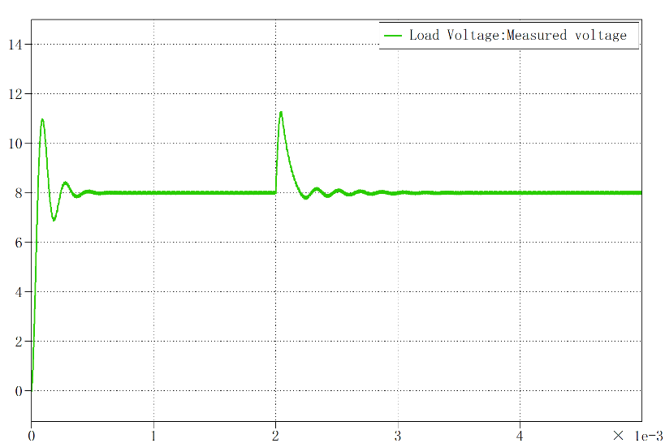
Figure 2. Simulation result of ideal conditions
It can be observed that there are generally two significant overshoots in the plot, where t=0s and t=2ms respectively. The output load is $2Ω$ initially, and has been changed to $8Ω$ after 2ms. It is apparent that the change of load causes the overshoot. Comparing these two overshoots, the first one takes less time than the second one to steady, this might because

Simulation results with non-ideal components
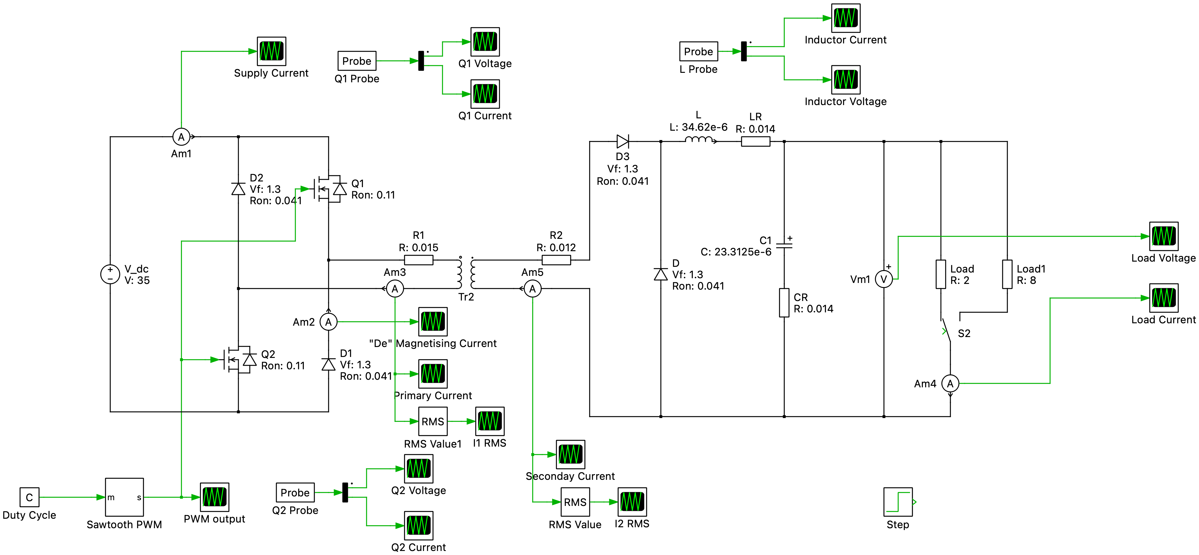
Figure1.1 Non-ideal Schematic With 35Vdc Input
Simulation Settings
The simulation settings of the non-ideal circuit were identical to the ideal circuit except the changes in component values as shown in the schematic above.
Results & Observations
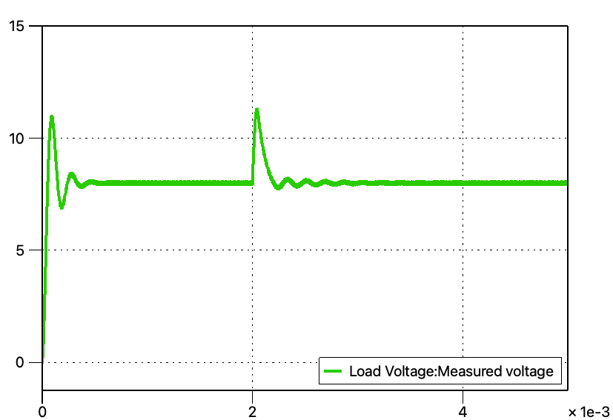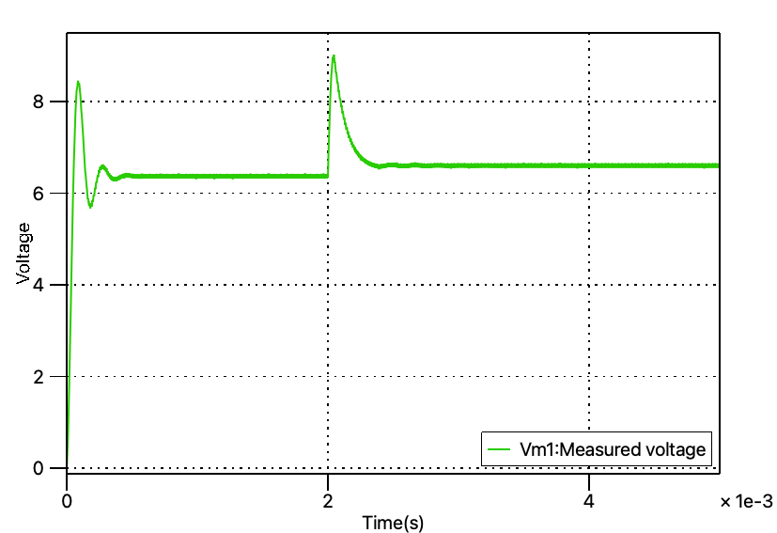
Figure1.2 Ideal(left) and Non-ideal(right) Output Voltage
Two major differences could be found by comparing the output voltage plot of ideal and non-ideal simulations. The first point is that the stable voltage on the load of non-ideal simulation is smaller than that of the ideal simulation. The second point is that in non-ideal simulation, the steady state voltage across a larger resistance load is higher than the voltage across a smaller resistance load.
The possible explanation to the first difference is that after taken the forward bias voltage on the diodes and the equivalent serial resistances into consideration, there would be voltage drops on every circuit component while the input voltage remains the same, which results in a relatively lower output voltage in the non-ideal simulation. In terms of the second difference, the changes in the voltage level are seemed caused by the difference in the load resistance, however, it is the difference in current which directly leads to the result. The larger load resistance would lead to a smaller current in both primary part and the secondary part of the converter. As the power rating of the converter and the turns ration on the transformer are consistent, the voltage drop across the components would hence be smaller when the current flowing in the circuit became smaller, thus, the steady state voltage across the load would be higher when a larger resistance load is applied to the circuit.
The peak to peak value of the ripples at the steady state voltage is around 0.08V, smaller than 0.1V that required by the customer. The ripples in the steady state voltage are mainly caused by the charging and de-charging process of the capacitor, therefore, the peak to peak value could be further reduced by using a capacitor with larger capacitance in the circuit. However, the feasibility of using a very large capacitor on the PCB is doubtful mainly due to the limited space on the board.
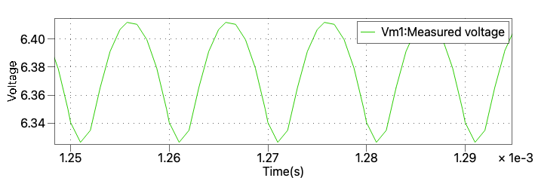
Figure1.3 Ripples at Steady State Voltage
Besides the observations on the output end of the converter, another simulation result that could guide the future practice is the current magnitude on the transformer. The RMS value of the current directly determines the heat losses of the converter while the current value has an inverse linear relationship with the load resistance, it is important to keep the current density on the wires at a safety region. In the case of copper wires, this figure should be around or below 5A per square millimeter according to the instructions while the thickest wire in the lab only has a cross sectional area of 0.39${mm}^{2}$ after considering the skin depth which has been calculated previously. The figures below are the RMS current values on the secondary winding under a small load(2$Ω$) and a large load(8$Ω$).
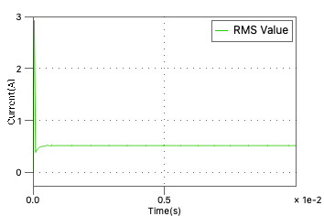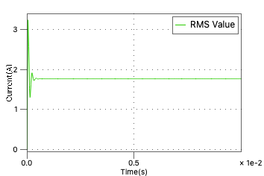
Figure1.4 RMS Current Value on Secondary Winding under 8$Ω$(left) and 2$Ω$(right) Load
The current value is roughly at 0.5A under big load and 1.8A under small load, which give an instructional idea on wire type selection in practice.

Simulation Results with AC derived input
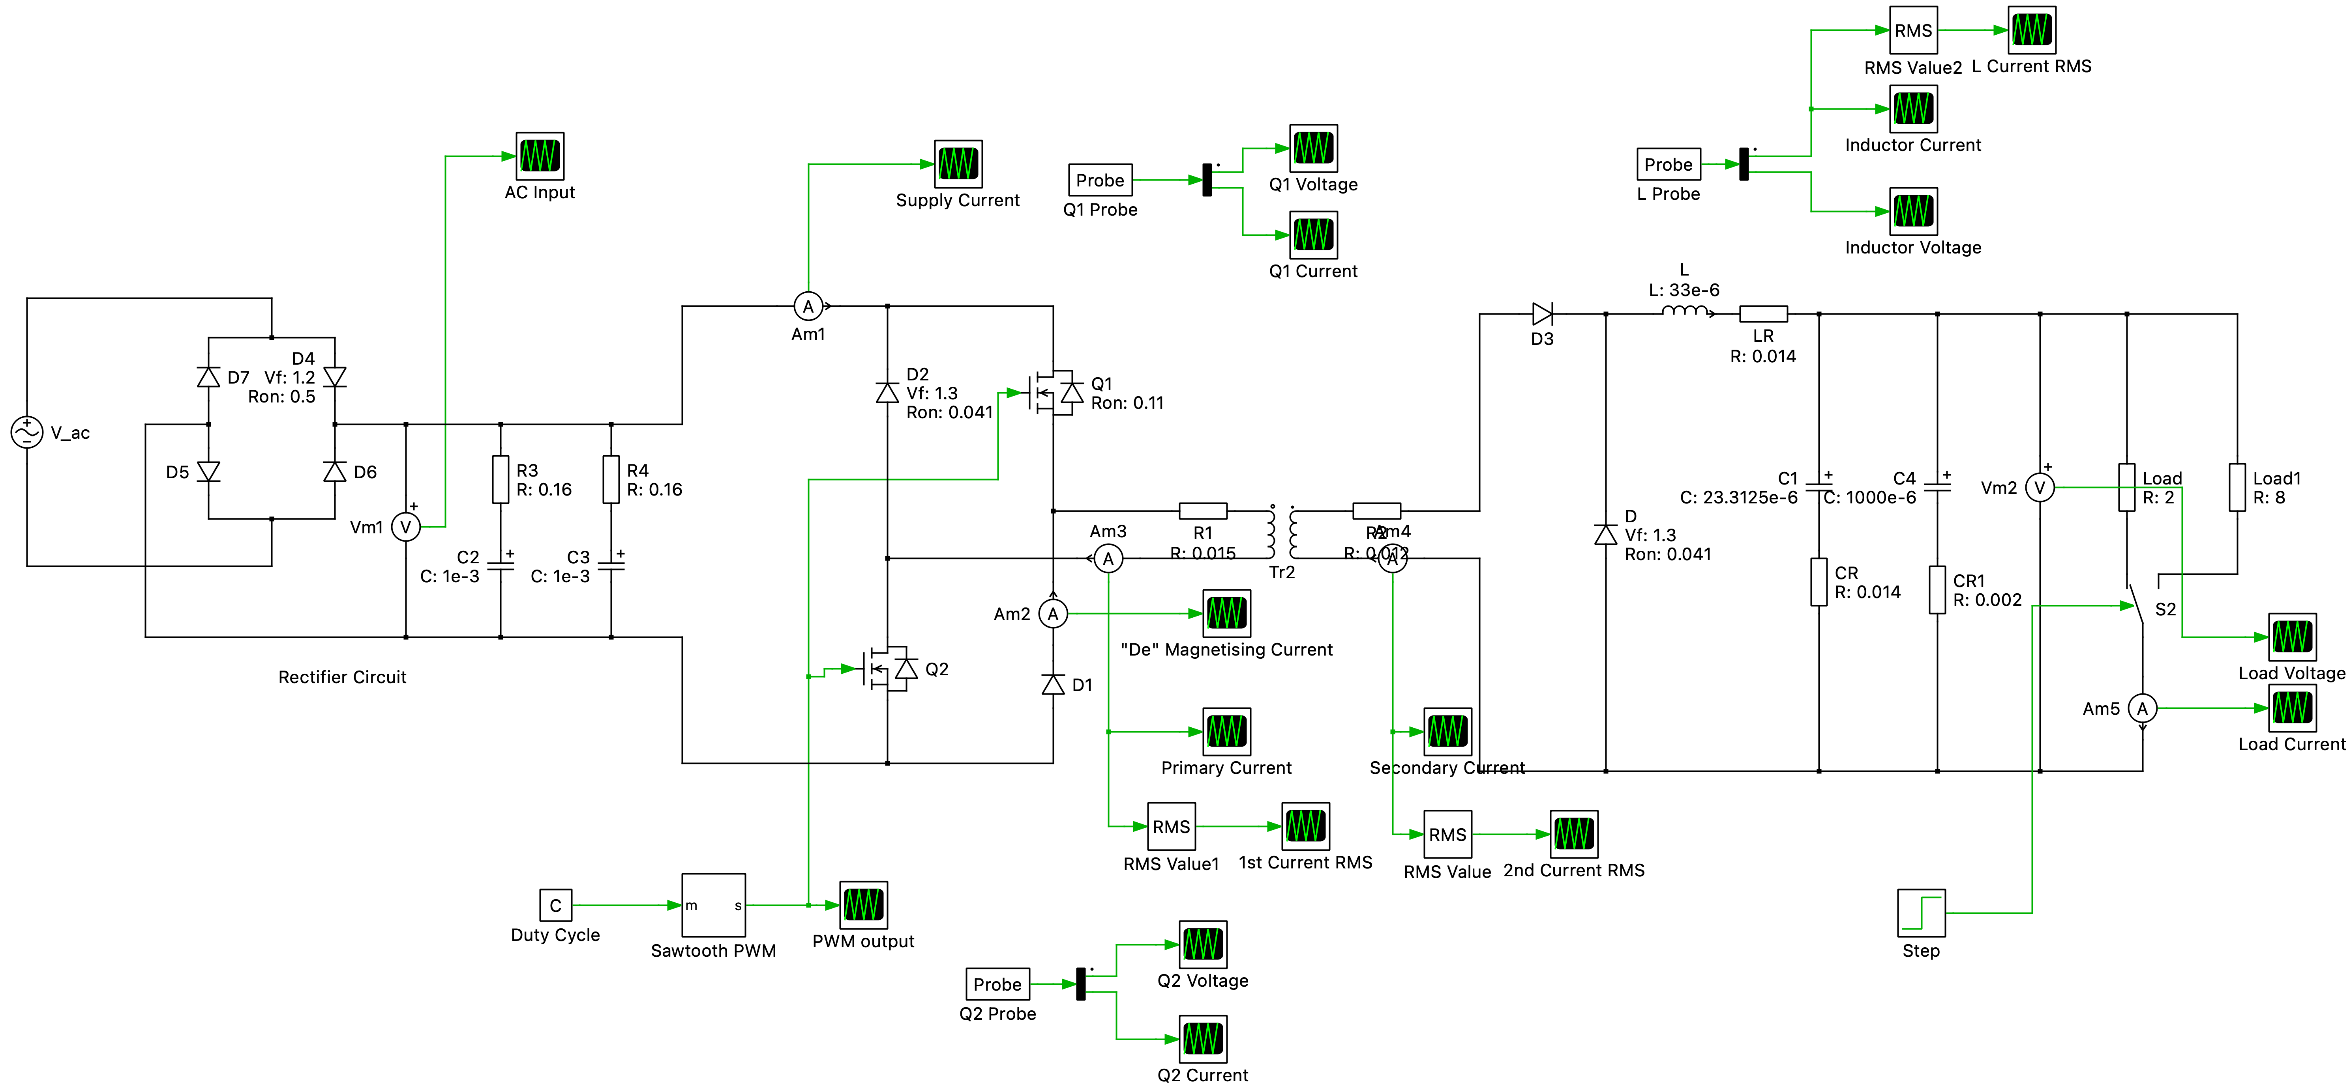
Figure2.1 Non-ideal Schematic with AC Input
Simulation Settings
The simulation time was increased to 0.2s to obtain the stable wave forms, the rest of settings were identical to the non-ideal circuit except the changes in circuit layout and component values as shown in the schematic above.
Results & Observations
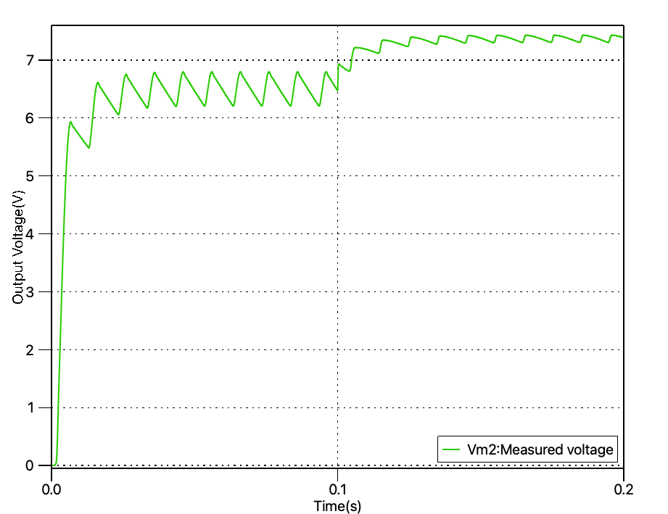
Figure3.1 Non-Ideal(left) and Non-Ideal with AC Input(right) Output Voltage
It is observed from the figure above that the ripples in the output voltage(not referring to the big ripples caused by the AC input) is around 0.005V, significant smaller than that in the non-ideal simulation. This change is due to a relatively large capacitor ‘CR1’added into the circuit. The capacitor

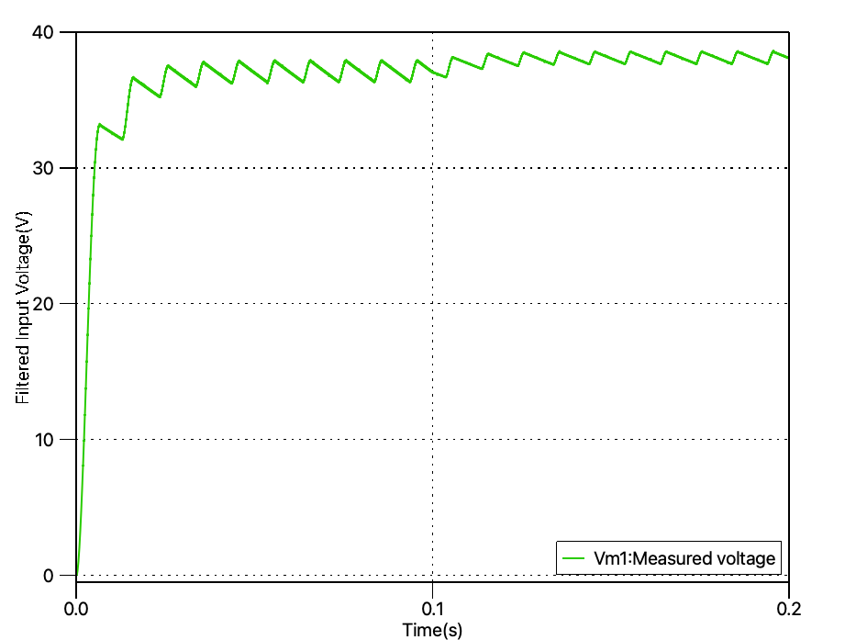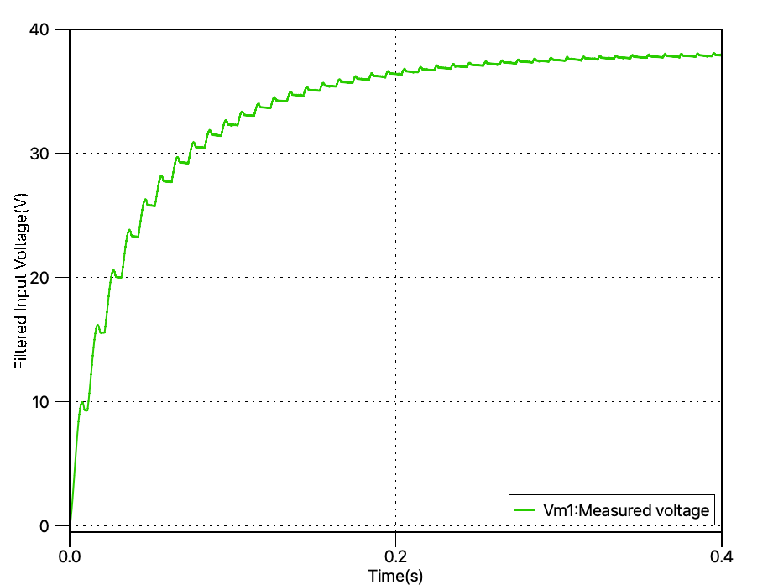
Figure3.2 Filter AC Input via 2uF Capacitor(left) and 20uF Capacitor(right)

Large Ripple
Small Ripple(why smaller, resistor impact)

Gate Drive Circuit
The gate driver circuit was implemented in order to provide electrical isolation between the control section of the converter and the high frequency power section. This isolation was necessary to provide safety between the high and low power components and to ensure reliable operation of the power electronics.
Figure X shows the schematic diagram of the gate driver circuit, with the MOSFETs represented as capacitors. The components within the gate driver circuit are carefully selected and arranged to enable efficient operation of the MOSFETs, which act as power switches in the converter.
In the following section, the operation of the gate driver circuit is explained in detail, with each component's purpose discussed. The selection and arrangement of components are critical for the proper functioning of the circuit, and a thorough understanding of the circuit operation is necessary for successful implementation.

Figure x: Schematic of the Gate Driver Circuit
In the gate driver circuit, the input signal was a square wave with a selected switching frequency of 100 kHz and a peak voltage of 15V. The MOSFETs, used as a power switch, required an input voltage between 12V and 15V, in accordance with its specifications. The input signal contained both AC and DC components, which necessitated the use of a coupling capacitor, C1, to block the DC components prevent the transformer from being saturated by it. If the capacitor was not used, there would be a duty cycle-dependent voltage across the transformer windings, which would cause signal distortion and potentially cause damage to the transformer. As a result of C1, a shift in the signal was caused with not peaks of approximately 10.5V and -4.5V. The capacitor value had to be kept relatively large to enable effective DC blocking and prevent signal distortion caused by the voltage drop at the capacitor.
The signal then enters a unity transformer, which provides galvanic isolation and protection between the control and power sections of the converter. The transformer in the gate drive circuit helps to ensure reliable and safe operation of high-power switching devices by allowing a safe signal transfer. To avoid time delays that can decrease system performance and reliability, such as increased power dissipation, reduced switching speed, and accuracy, a low leakage inductance is required for the transformer. Trifilar winding was used to reduce the leakage inductance. Trifilar winding involves winding wires closely together with the same number of turns, which reduced the amount of flux leakage between the windings, thus reducing the leakage inductance.
The role of the second coupling capacitor in the gate drive circuit was to restore the voltage drop within the signal, maintaining voltage levels of 15V and 0V. Meanwhile, the Zener diode functioned to clamp the voltage at a safe level, providing the MOSFET with protection from overloaded conditions. During turn-on and turn-off, the voltage levels could rise above the MOSFET's voltage rating of 20V, potentially damaging the device. However, this risk was mitigated through the use of a Zener diode with a breakdown voltage of 18V. Although the MOSFET had a maximum gate-source voltage of 20V, a voltage of 18V was used to provide an additional safety margin, especially since the MOSFET only required 12V-15V to operate.
The MOSFETs was represented with capacitors, C5 and C6, because the gate terminal of a MOSFET behaves like a capacitor, and it has to be charged and discharged through a resistor in order to turn the MOSFET on and off. The gate capacitance is typically much larger than other capacitances in the circuit, which is why it is represented separately as a capacitor. By representing the MOSFET as a capacitor, the simulation program can accurately model the charging and discharging of the gate capacitance and provide accurate results for the circuit's behaviour.
The gate resistor, RG, was responsible for charging and discharging the gate capacitance within the MOSFET which meant choosing a correct value for it was mandatory. Since, a small value of the gate resistor, caused the gate capacitor to charge faster increasing the turn on speed and thus decreasing the power losses. However, it can cause excessive current to flow into the gate at turn on, which can potentially damage the MOSFET. Thus, a suitable value limiting the current but providing a fast enough rise time was selected.
The gate source resistor, RGS, was a necessary component responsible for removing the charge stored by the parasitic capacitances, C5 and C6, between the gate and the source. Without this resistor, the MOSFET becomes unpredictable and may have floating voltages due to parasitic interference and noise. Since it was responsible for the removal of charge, its value was dependent on the time constant, which meant that a large RGS would increase the switching times leading to higher power dissipations and thus thermal losses.
From a selection of the correct components the following result was produced within figure x. It displays a peak at 14.3V and -0.7V approximately. With the voltage drops in the peaks caused by the Zener diode in forward mode.

Figure x: Output of the capacitors representing the MOSFETs

Conclusion

For gate drive: In conclusion, the gate driver circuit plays a critical role in the proper functioning of the MOSFETs. The circuit components were carefully selected and arranged to enable efficient operation of the MOSFETs. The use of coupling capacitors, a unity transformer, and Zener diodes provide reliable and safe operation of high-power switching devices, while the proper selection of gate resistors and gate-source resistors aids in reducing power losses, limiting current flow into the gate, and removing charge stored by the parasitic capacitance.

